**Singleton**

**A general UML class diagram of a Singleton design pattern.**

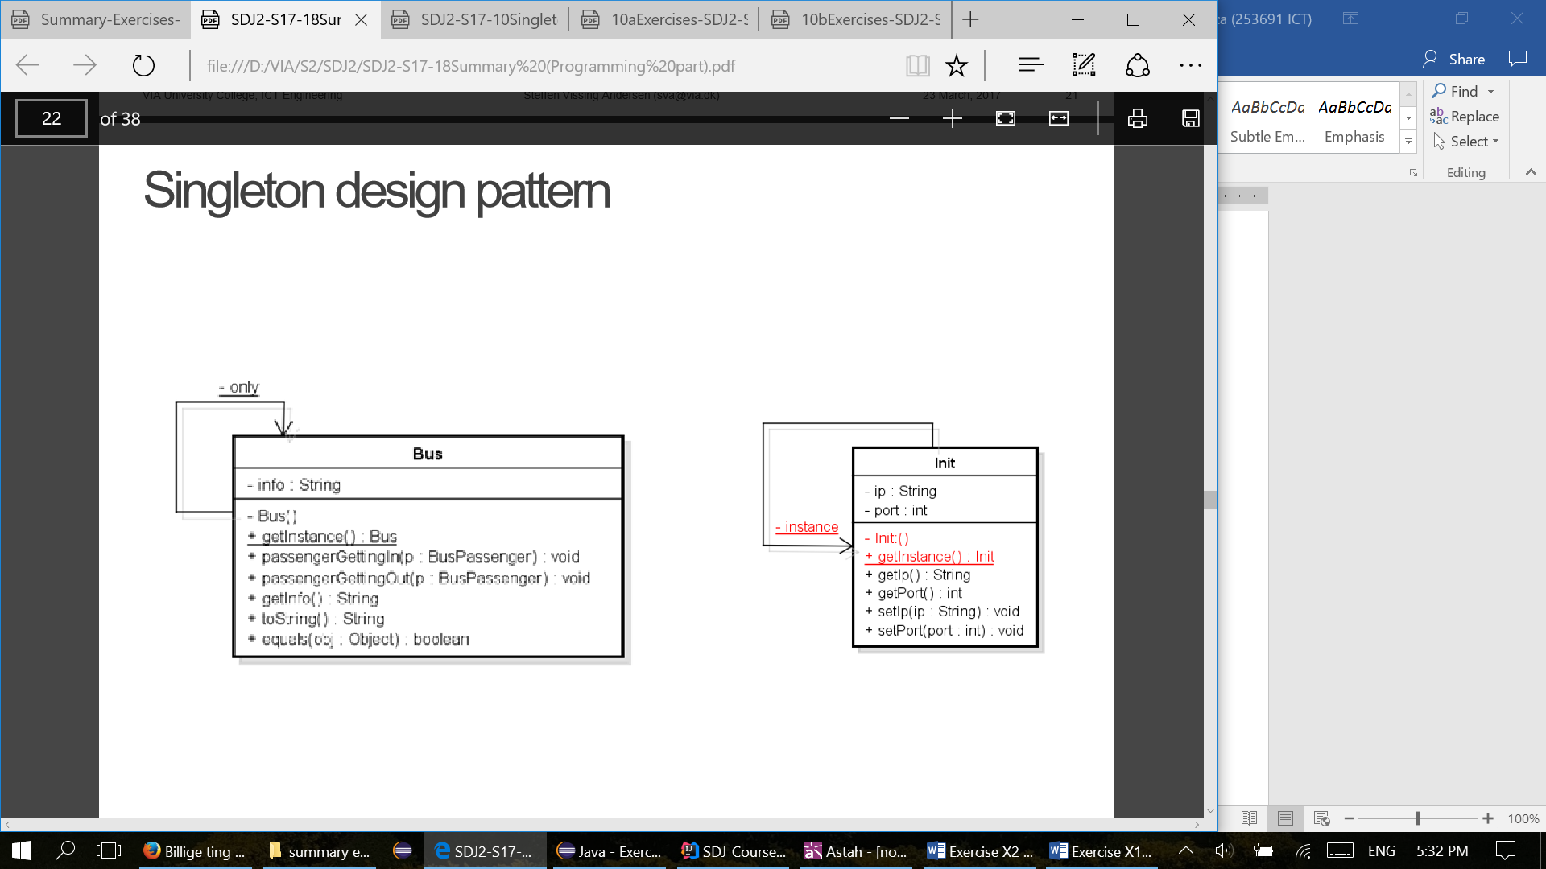

**The overall purpose for the Singleton design pattern.**

Singleton involves a single class which is responsible for creating only one object of its kind. This class provides a way to access its only object which can be accessed directly without the need to initiate the object of the class.

**What makes it a singleton:**

- private static Singleton instance - Private static class variable of the same type as the class that is the only instance of the class.

- private Singleton() – Private constructor to restrict initiation of the class from other classes.

- public static Singleton getInstance() – Public static class method returning an instance of the class, this method has to ensure that only one instance is created.

**How to use a Singleton design pattern.**

Singleton pattern is mostly used in multi-threaded and database applications. It is used in logging, caching, thread pools, configuration settings etc.

To use the singleton class, we need to have static member of class, private constructor and static factory method.

* **Static member:** It fills memory only once because of static variable which contains the instance of the Singleton class.
* **Private constructor:** It will prevent to instantiate the Singleton class from outside the class.
* **Static method:** This provides the global point of access to the Singleton object and returns the instance to the caller.

**Code examples for the Singleton pattern.:**

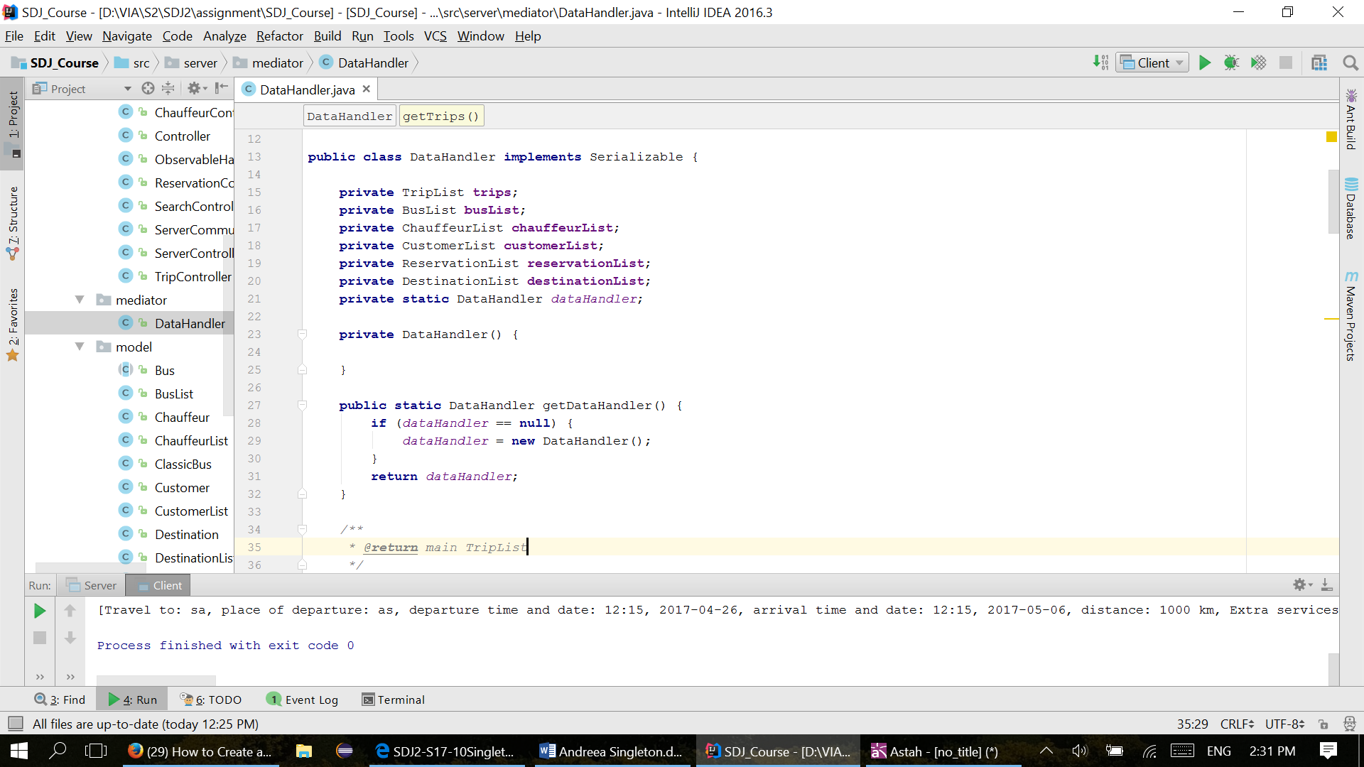

**The UML class diagram of the Singleton design implemented:**

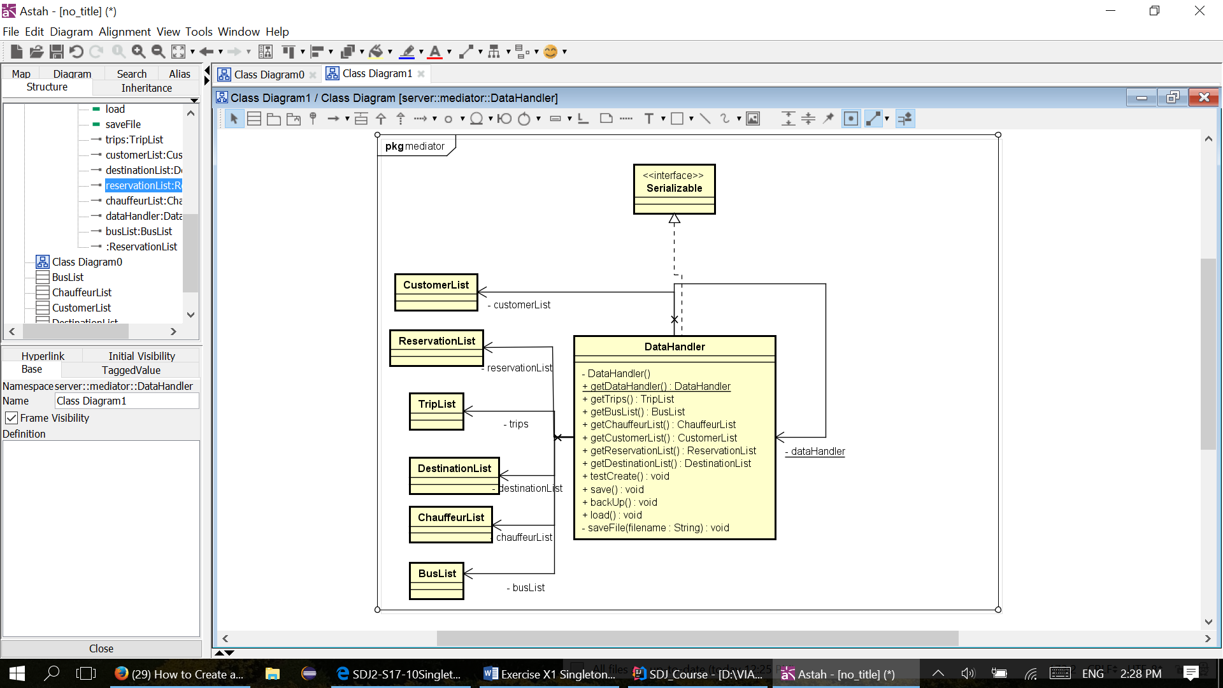

**Testing of our Singleton design pattern:**

* We have inserted printout statement in the getInstance() method in which we are printing hashcode of datahandler object to the console. By doing this we can easily see if we are using only one instance of datahandler in the whole project.
* After running project and trying several parts of program, we got following output in the console:

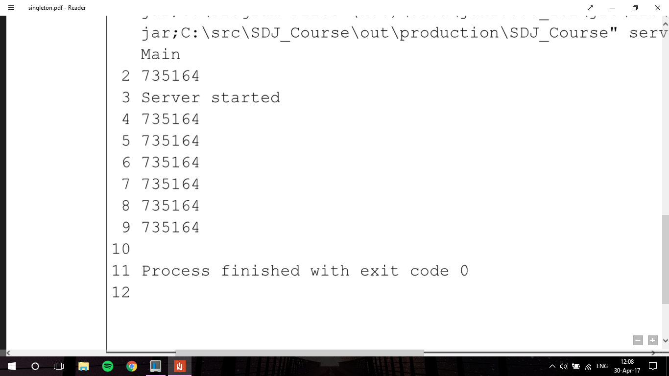

* Number 735164 is the hashcode of the datahandler instance. Since the number is the same in all printouts, we consider test as a success, we have concluded that we implemented singleton design pattern correctly.